Practical 19:

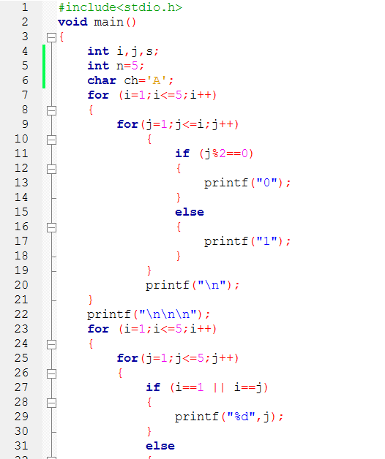

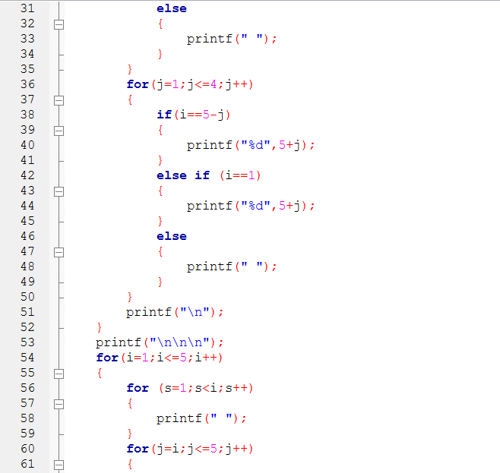

19-i:

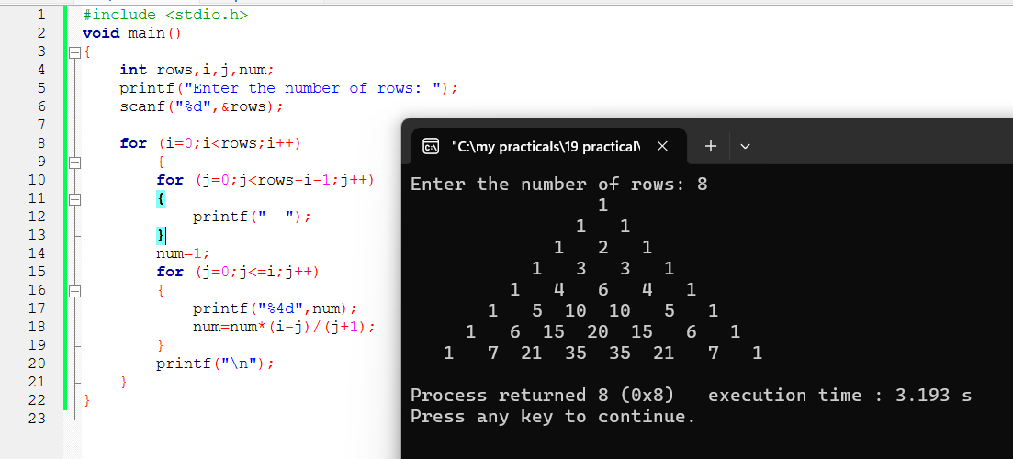19-ii:

